Assignment 2

# Subject: MCEN90044 Electromagnetic Technologies

# Name: Shiyu Zhang

# Student Number: 683557

Part 1

1. Group Photo

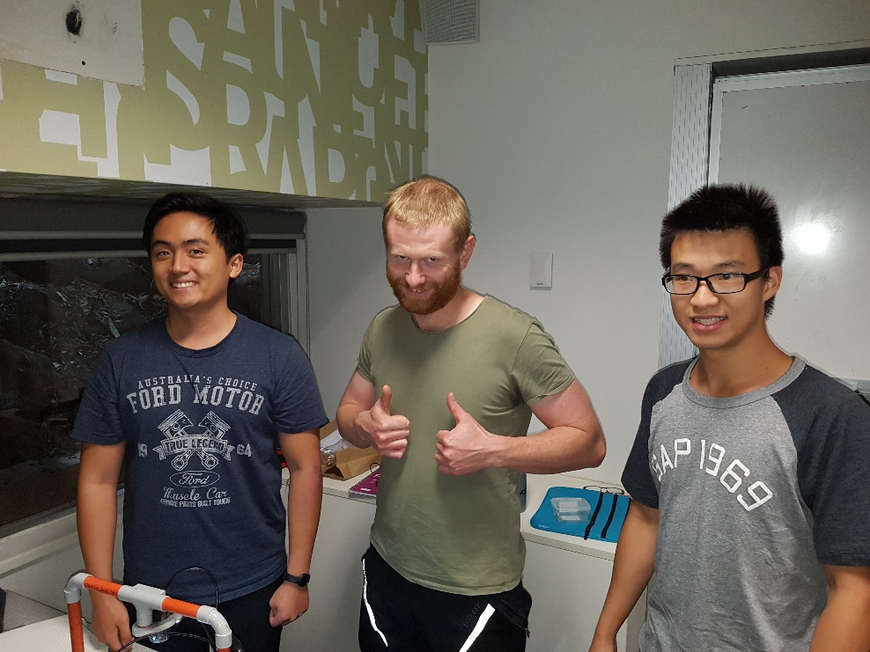

1. The hand calculation of the analytical expression for torque constant Kt is shown in the figure below.

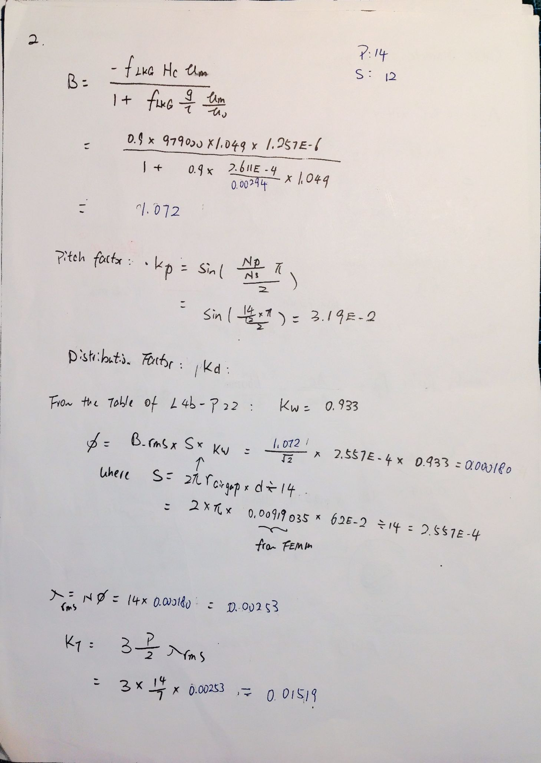

1. A FEMM model has been created as the figure below show.

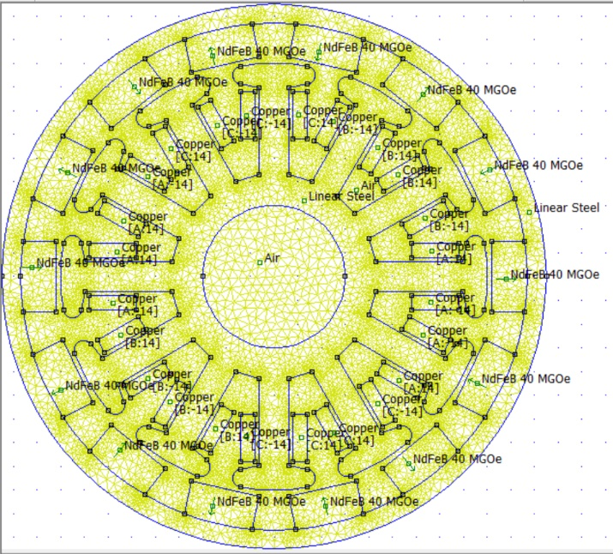

The hand calculation result and the FEA model with high permeability linear steel of torque constant can be seen from the table below.

|  |  |
| --- | --- |
| Method | Torque Constant(Nm/A) |
| Hand Calculation | 0.01519 |
| FEMM output to Matlab | 0.01450 |

There are slight discrepancies between the two results. One of the reasons might be the flux leakage factor in hand calculation is a rough estimation, whereas FEMM can model this phenomenon quite well. The other reason might be the air gap between the coil area and the motor slot wasn’t included into consideration in hand calculation whereas that has also been taken care of in the FEMM model.



After looking up the 1806 motor catalogue, it can be found that the motor was built using laminated silicon steel to reduce hysteresis loss and core loss. Therefore, the B and H relationship would be nonlinear.

To improve this, the linear steel blocks in FEMM can be replaced with M22 Silicon Steel.

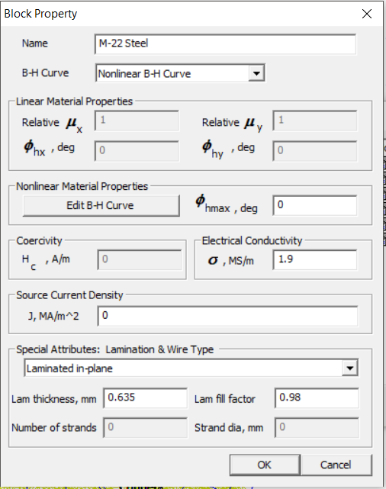

And the simulation result has been shown in the figure below.

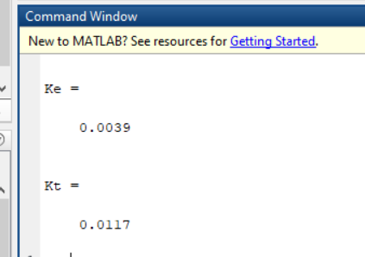

Kt is increased from 0.0014 to 0.017.



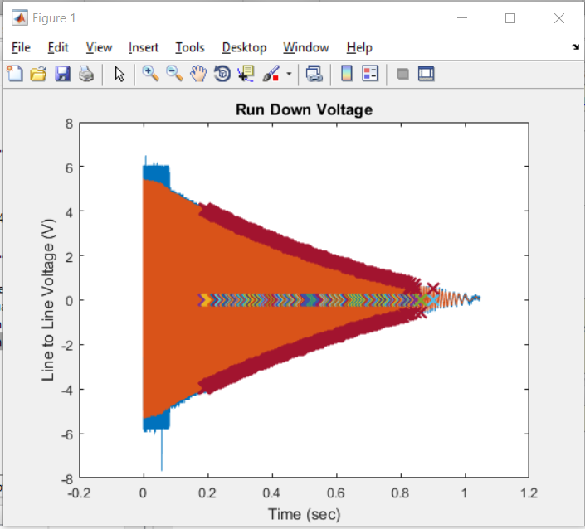

The experimental torque can be found by modifying script *OutrunnerVideoExample_Part4.m* reading the back emf voltage csv file collected in the experiment (figure on the left), and the result has been found to be Kt = 0.0050.

To sum up with, the hand calculation, FEA, and experimental results has been found in the table below.

|  |  |
| --- | --- |
| Method | Torque Constant(Nm/A) |
| Hand Calculation | 0.01519 |
| FEMM output to Matlab (Improved to M22 steel) | 0.01450 |
| Experimental | 0.005 |

The cause of difference between Hand Calculation has been discussed in question 4. However, the Torque constant found by experiment is significantly smaller than that found by the rest of the method. This is due to different kind of loss that is not included in consideration when we model the system in FEMM and doing hand calculation. These losses include: 1. Conductor loss due to resistance in conductor; 2. Core loss due to hysteresis and eddy current; 3. Bearing loss due to the friction of the bearing in motor; 4. Solid loss due to eddy current in non-laminated materials.

1. The calculation of **wire fill factor** and **torque** with J = 10A/mm is shown below.

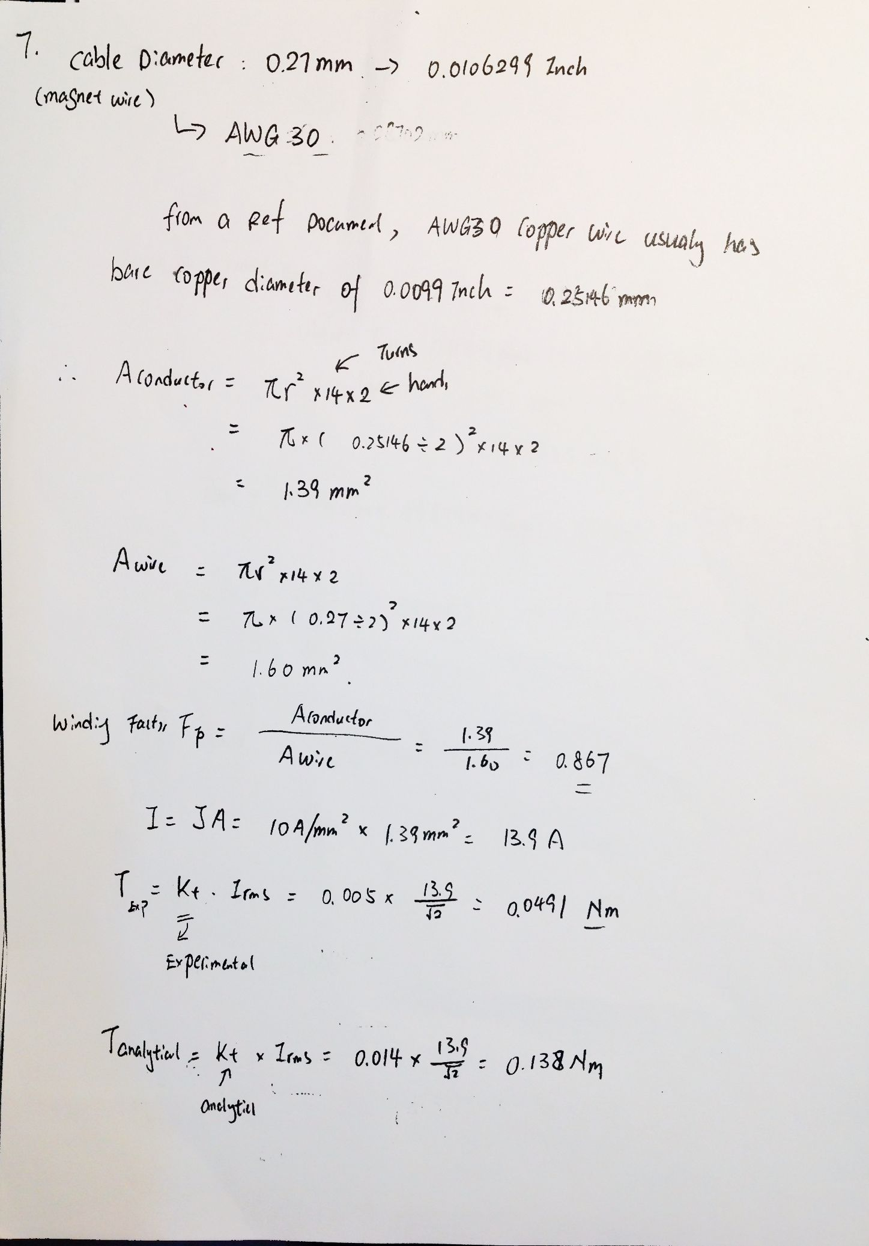

1. The plot of torque vs current density has been shown in the figure below using Q8.m in the appendix.

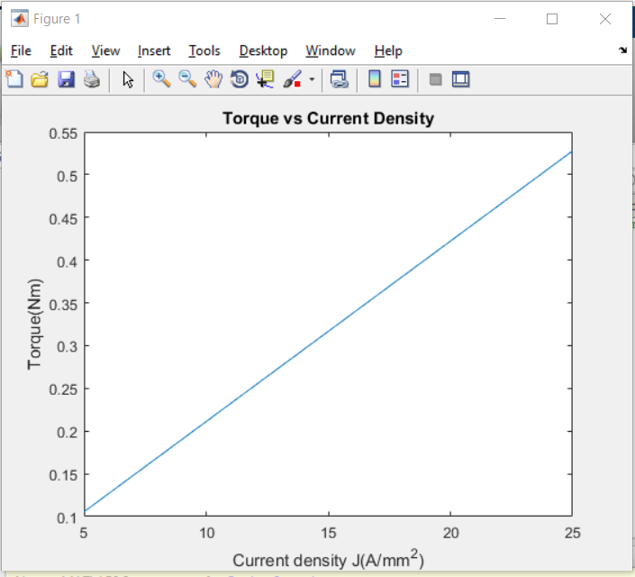

1. 

Know that the Motor velocity constant Kv is = 2400 rpm/V = 251.33 rad/s*V.

Therefore, the back emf constant Ke = .

It is known that Ke = Kt when there is no loss.

However, Ke is very different from Kt_calculated_from_matlab = 0.014, and even smaller than Kt_experimental = 0.005.

This might due to the



By adjusting “local element size along the line” as well as “Maximum segment degrees” for arcs in the femm model, the following execution time has been estimated by printing the systems clock in the Lua script, and the Torque constant was estimated y running the provided Matlab script.

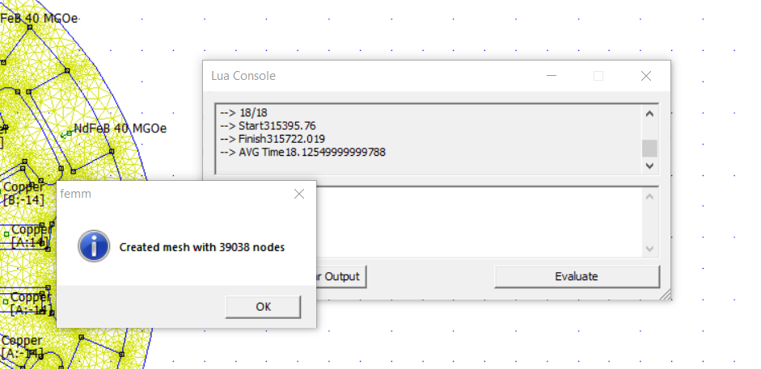

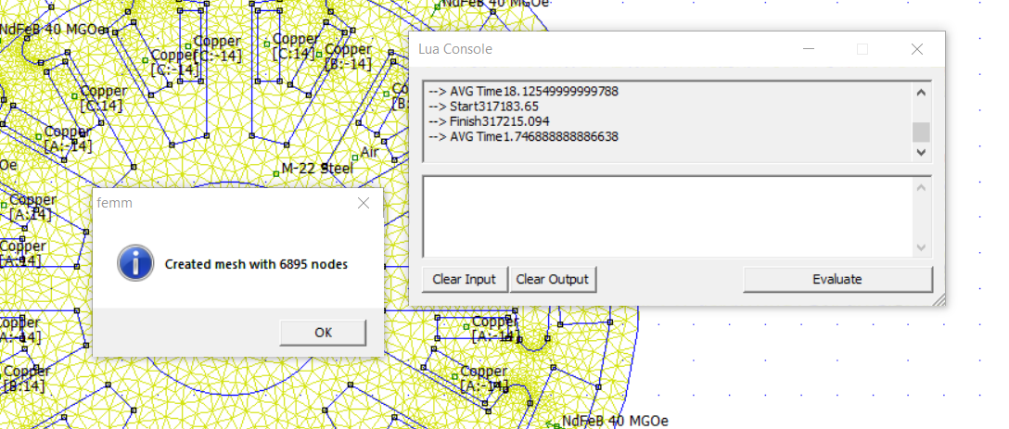

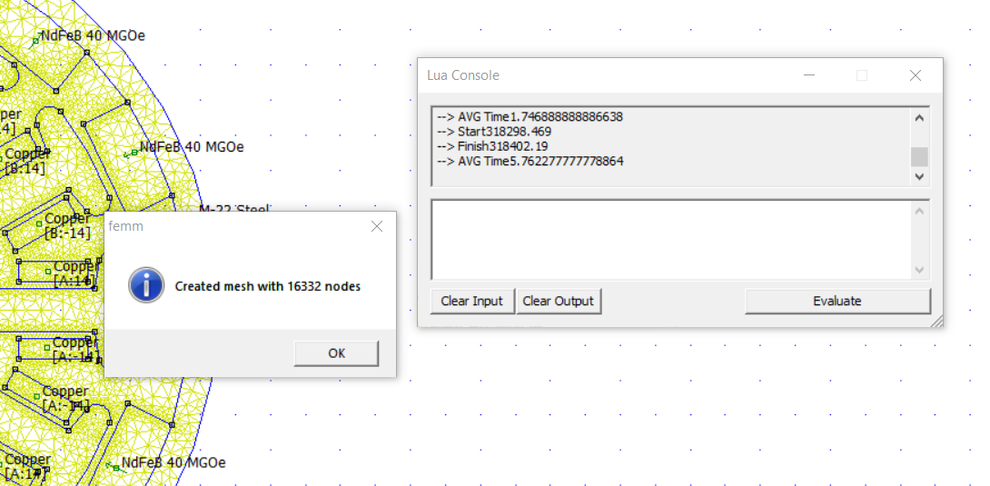

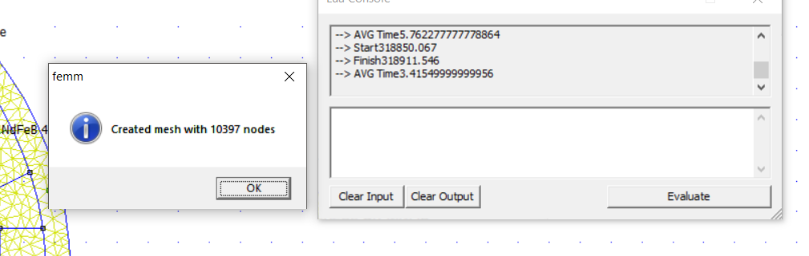

|  |  |  |
| --- | --- | --- |
| Number of nodes | Execution Time(s) | Torque constant from Matlab (Nm/A) |
| 6895 | 32 | 0.0118 |
| 10397 | 61.479 | 0.0118 |
| 16332 | 103 | 0.0117 |
| 39038 | 326.259 | 0.0117 |

**As shown in the table above, number of nodes has significant impact on running time but only have minor effect on the Torque constant calculation.**

Part 2

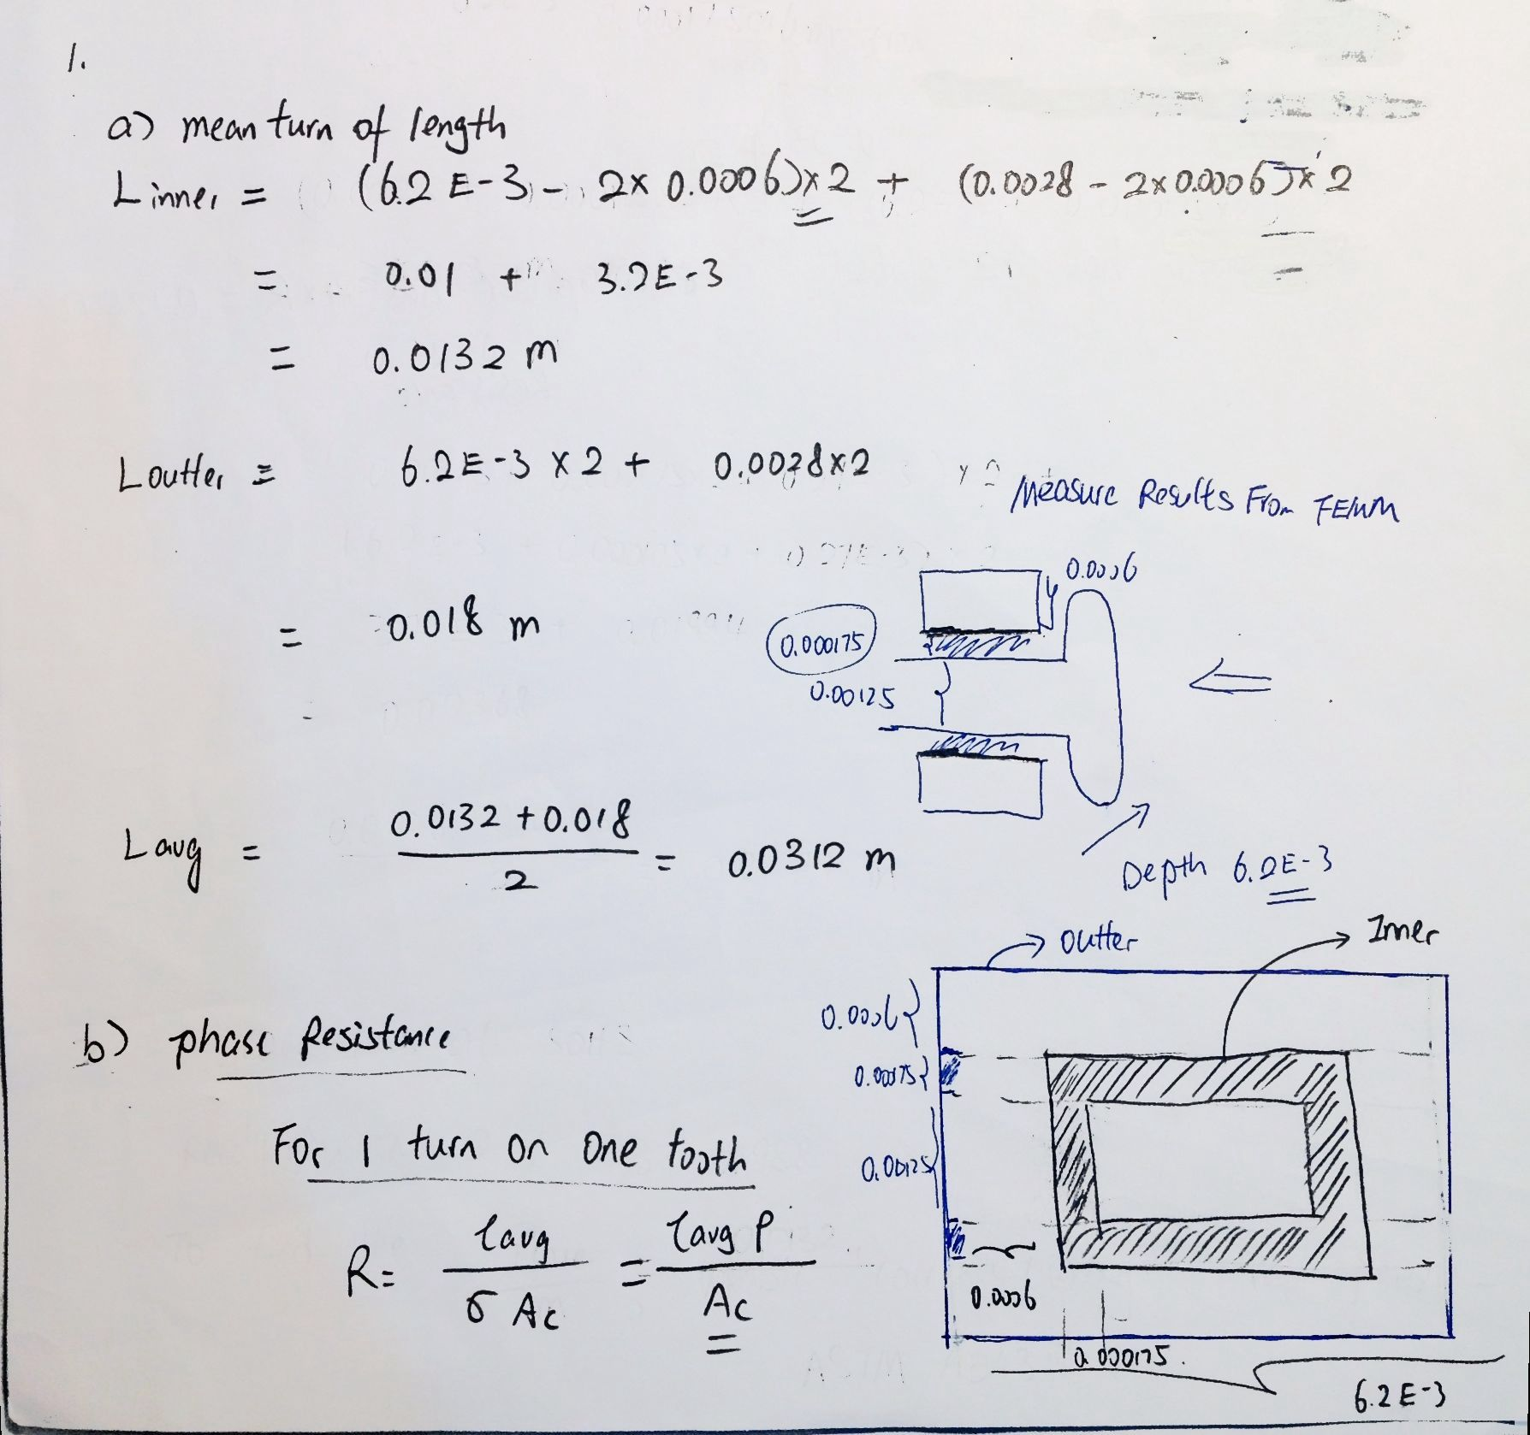

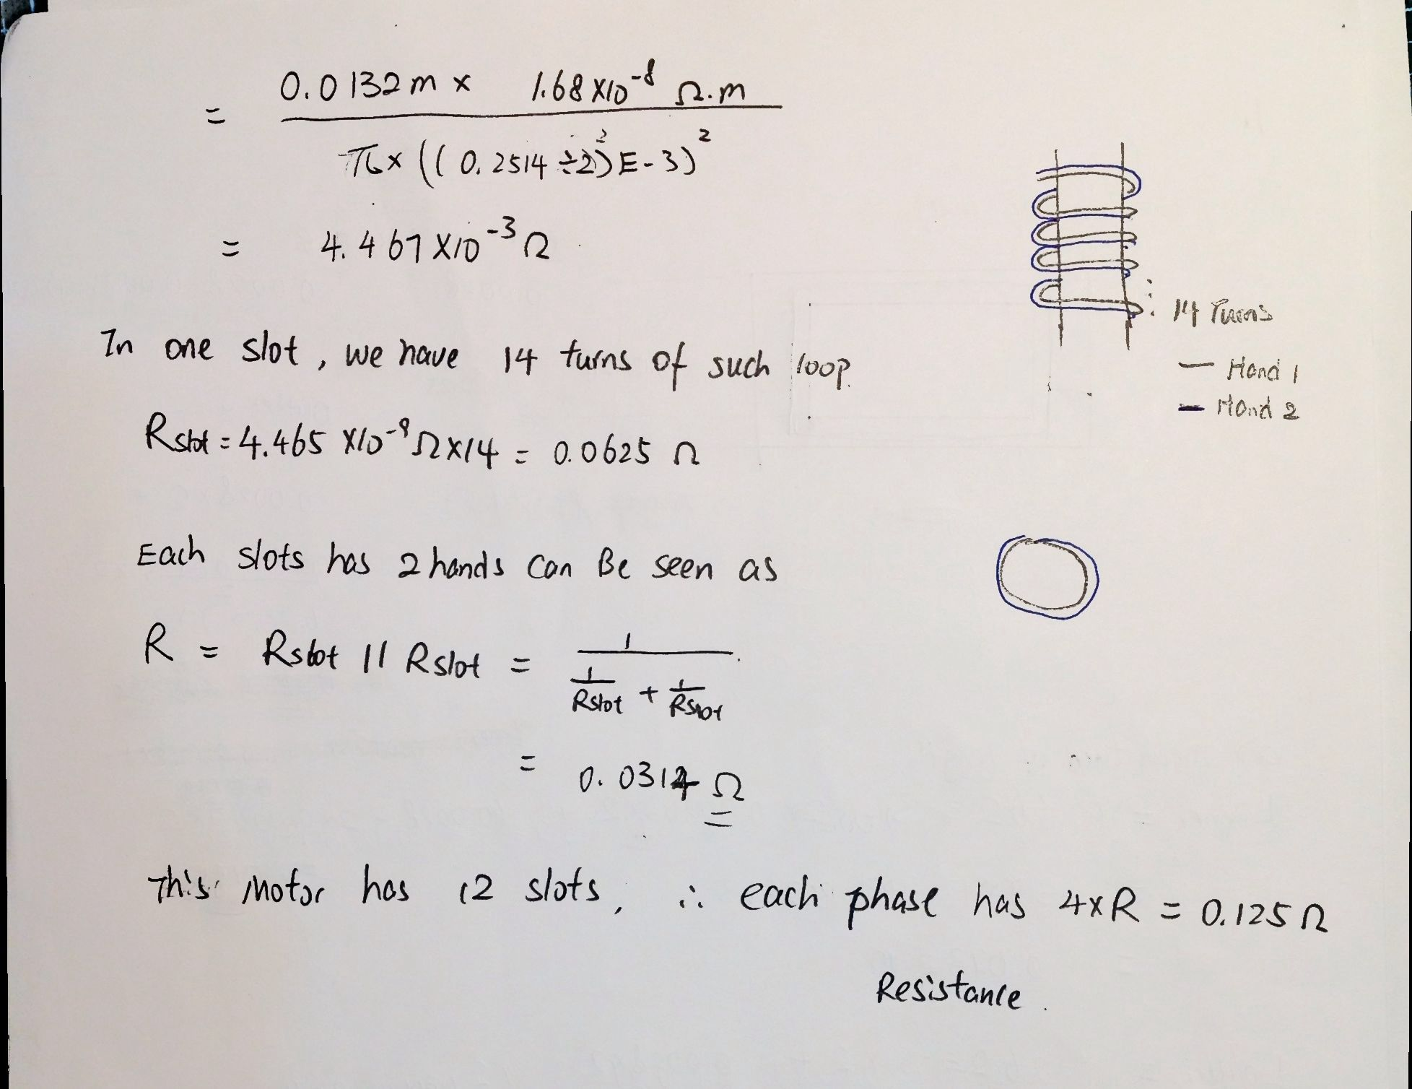

1. Find core loss

To find core loss at 50Hz, Table at Page 4 of document 1 in Appendix is used, because the thickness aim for this steel is 0.25mm, which is the closest to 1806 motors lamination thickness, 6.2mm/30 level = 0.21mm.

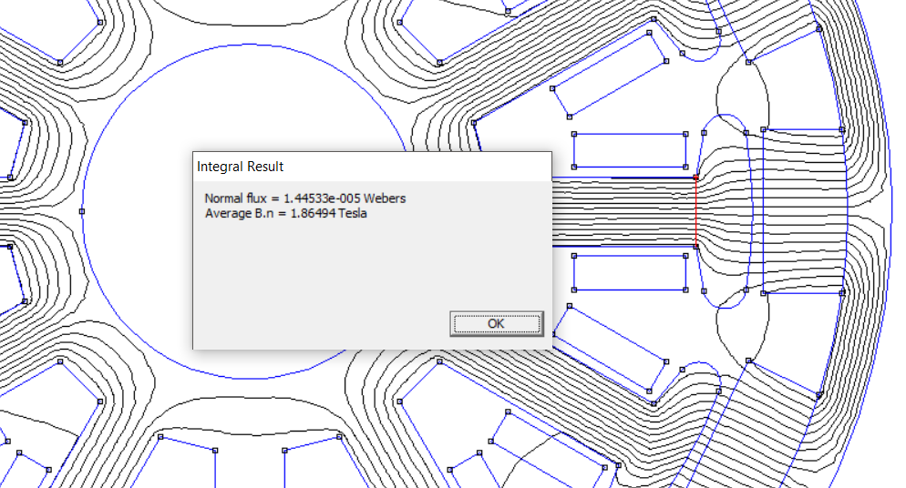

Recall from part 1, B = , therefore from the table aforementioned, .

Its know that core loss consist of hysteresis loss and eddy current loss, which is cause by the reversal of magnetisation, and the inducing current only in the part of the motor which has coil wrap around, which is the stator in this case. Therefore, the mass of the stator has been found by

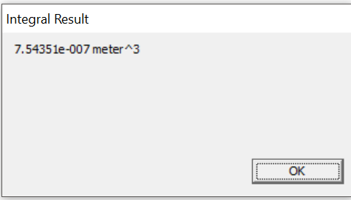

So, the mass for the 1806 motor rotor is = E-3 Kg, therefore

where 2 is the fabrication factor due to the edge damage in lamination steel sheet during production process.

3. No load/ spinning loss

It can be seen from the appendix of the assignment sheet that the moment of inertia on z axis for 1806 motor is 796.66972e-9 Kg*m^2.

Modifying Example_L5c.m, the plot of Spinning power loss power Vs Speed is shown in the figure below.

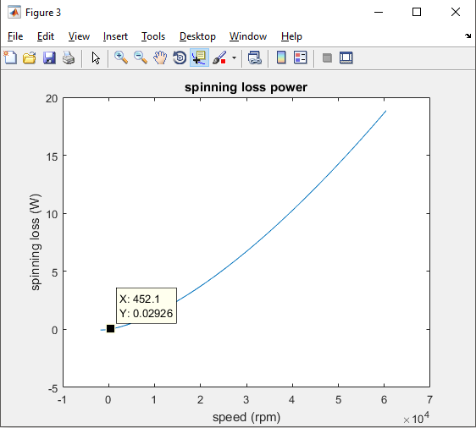

A reasonable running situation for this specific motor is under 11V will leads to 2400KV*11V = 26400rpm.

The RPM of the motor can be calculated by

Therefore, the spinning loss given by the curve above roughly 0.02926W.

4.

The rotor mass is given by 8.72625g = 8.72625E-3Kg = 0.0856E-3 N = 0.000085 KN

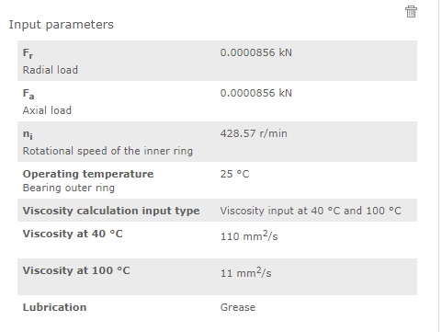

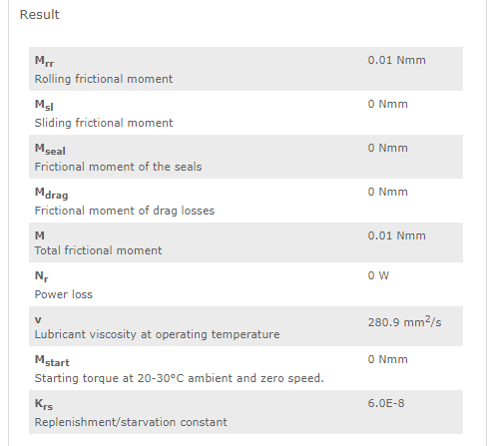

It is given by the skf website that Ploss = 1,05 x 10–4 *M*n, where M is the total friction moment which is 0.01Nmm, n is the rotational speed [r/min].

Therefore .

5.

Analytical estimation of spinning loss

To the extent of this assignment, the spinning loss is consisting of the core loss and the bearing loss.

And it can be seen from the previous part of this assignment that core loss at 50Hz is

And the bearing loss is . Therefore P_spinning_analytical = 0.0159W.

The result of spinning loss can be sum up in the following table

|  |  |
| --- | --- |
| Method | Spinning loss(W) |
| Analytical | 0.0159 |
| FEMM output to Matlab |  |
| Experimental | 0.02926 |

The different among three might cause by Solid loss due to eddy current in non-laminated materials which hasn’t been account for in FEMM and analytical analysis, whereas that exist in the real world.

6.

Efficiency = , the detailed calculation has shown below.

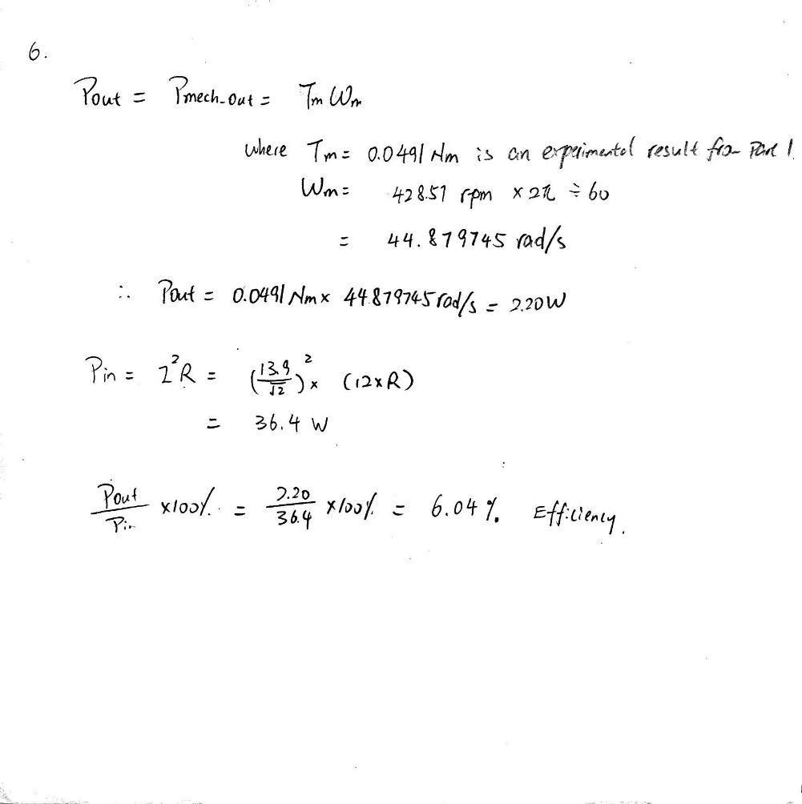

Bonus work attempt

The Matlab script that used to control and collect data from FEMM has been downloaded and modified.

The Start User-Defined Parameters are set as following with reasoning in the comment. The full code is attached in the appendix section.

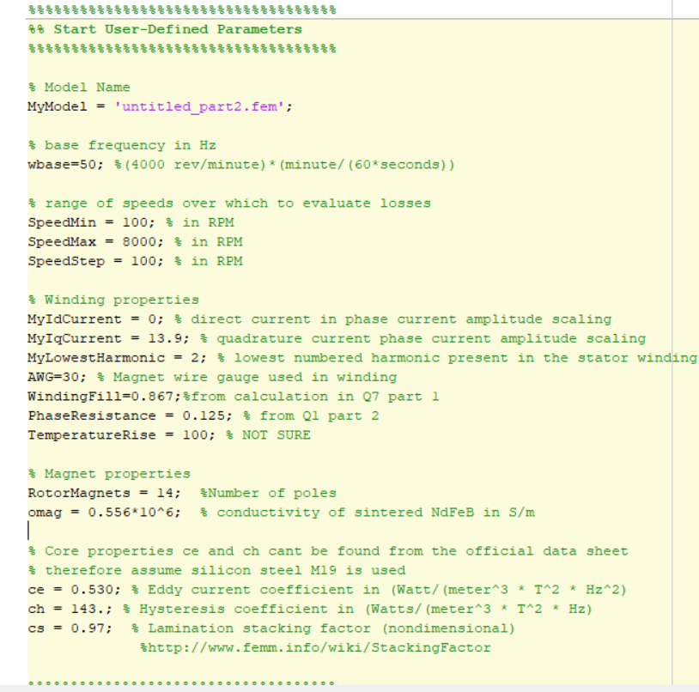

The plot

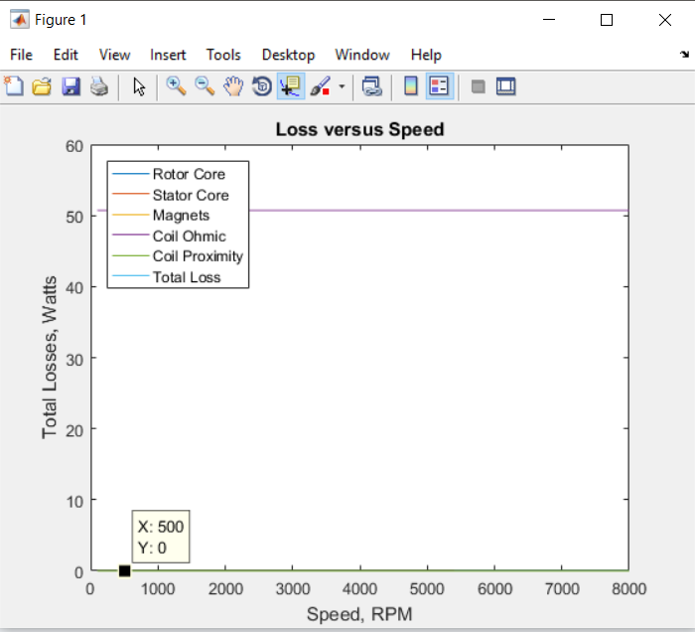

The result is not really